**Bank Alfalah Islamic Premier** Proposition offers exclusive perks for Shari’ah compliant banking solutions that are well tailored to suit high net worth customer’s unique and individual needs.

**New Islamic Premier Account Opening:**

* In case of opening an NTB Islamic Premier Account, Islamic Premier tagging and threshold marking shall be done at the time of account opening in the system by the branch.
* In case of a new Islamic Premier Account being opened by an existing client, IOM must be submitted with the Islamic premier account opening form for tagging of existing client ID to Islamic Premier and threshold marking. This should be uploaded on workflow along with the Islamic Premier account opening form and sent to CAO.
* All Islamic Premier accounts shall only be entertained on Islamic Premier Account Opening Forms

**Client Upgrade Process**(For ETB clients who want to migrate existing account(s) to Islamic Premier)

* Qualifying clients will be tagged ‘Islamic Premier’ on a quarterly basis by the Islamic premier proposition team
* For out of cycle upgrades, client eligibility should be checked by the branch based on last three months average balance, which should be as per Islamic premier thresholds i.e.

|  |  |
| --- | --- |
| **Type** | **Minimum Threshold (Quarterly Average Balance)** |
| **CASA (Current Account/ Saving Account)** | PKR 3 Million (or equivalent FCY) |
| **TDR* (Term Deposit Receipt)** | PKR 5 Million (or equivalent FCY) |

– Terms and Conditions Apply

* IOM (approved by Islamic Premier Proposition Team/ Head of Cross Sell, Liabilities and Product Management) should be uploaded on rosetta for CIF tagging and Islamic premier threshold marking via CAO (i.e. Prem3M, Prem5M or Prem7M, whichever is applicable) for qualifying clients only
* CAO will change Customer Tagging, which should be validated by the branch through the following T-24 screen.

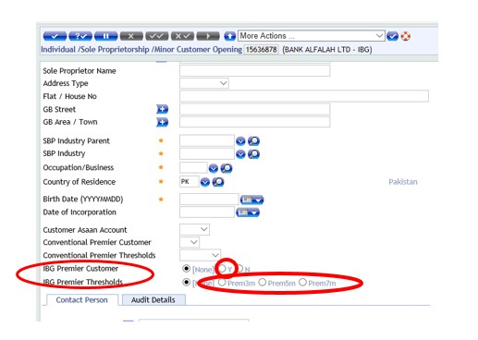

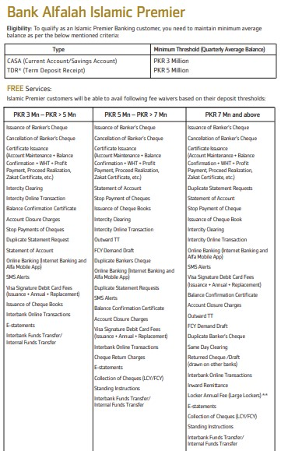

* These charges are subject to change on half-yearly basis.
* Apart from this, all bank service charges will be applicable as per Bank Alfalah Islamic's current SOC.
* In addition to above, all applicable Government levies will also be recovered.
* Eligibility criteria, deposit slabs and list of charge waivers are applicable in PKR or equivalent in foreign currency.
* Islamic Premier Customers not maintaining the required quarterly balance as per the eligibility criteria mentioned above will be downgraded.
* Upon downgrade, all benefits and privileges will be discontinued
* Currently, this facility will be available in limited cities only.

**Exclusive Perks and Benefits: Mentioned below is a brief description related to unique selling points of Bank Alfalah Islamic Premier Proposition:**

|  |  |  |
| --- | --- | --- |
| **S#** | **Unique Selling Point** | **Brief Description** |
| 1 | **Top Notch Alliances** | The customers can eat shop, spend and enjoy quality life through compelling offers at exclusive dining, shopping, fashion, travel and lifestyle ventures, both locally and internationally. |
| 2 | **Fast Tracked Services** | Customers can become a part of the unmatched banking services at an expedited turnaround time. |
| 3 | **Fee Waivers** | Customers are entitled to general banking fee waivers and rate breaks on Islamic cross sell products. |
| 4 | **Relationship Driven Banking** | A skilled and trained relationship team will be available to assure quality Islamic Premier Banking Experience. |
| 5 | **Accelerated Orbit Rewards** | Customers can earn accelerated orbit rewards upon availing and utilizing Islamic Premier deposit accounts and Islamic Premier card. |
| 6 | **Dedicated Channel Strategy** | Customers are provided with ease in access to bank’s helpline through separate Contact Center Helpline Number 111 225 226 along with a faster complain resolution arrangement. |
| 7 | **Higher Spending Limits** | Customers can avail higher daily spend limits that gives them a flexibility to be in control of their transaction. |
| 8 | **Lounge Access and Benefits** | Customers can witness seamless services at designer Bank Alfalah Islamic Premier lounges. These include conference room benefits for any official meetings, refreshed way of banking through Espresso Coffee and Cookies and a dedicated relationship management team available at lounges to serve our priority customers. |
| 9 | **Airport Lounges** | Complimentary access to over 1100 global lounges through your Lounge Key* in more than 300 cities. Key destinations include Paris, New York, London, Dubai and Budapest. Guests will be charged US $ 27.00 per guest per visit.  Access to over 1300 Airport Lounges through Priority Pass. |